Safety Placard

Cosmic Ray Detector -- New Trier Northfield

FIRE * * * * POLICE * * * * AMBULANCE
Press 8-911
NO known hazards
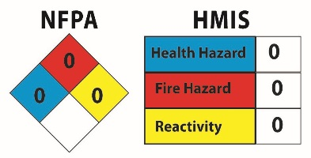
Electricity: 120 v AC to 5 v DC, under 3 amps
No Personal Protection Equipment required.
Responsible Staff Persons
Robyn Ward, Science Department D311
New Trier Township High School: 847 784-7630
Nathan Unterman AAC Room A405
New Trier Township High School: 847 784-7768
Cell 773 758-0464 Land 773 338-0464
Date of above information: 14.January.2020

Safety Placard

Cosmic Ray Detector -- New Trier Northfield

FIRE * * * * POLICE * * * * AMBULANCE
Press 8-911
NO known hazards
Electricity: 120 v AC to 5 v DC, under 3 amps
No Personal Protection Equipment required.
Responsible Staff Persons
Robyn Ward, Science Department D311
New Trier Township High School: 847 784-7630
Nathan Unterman AAC Room A405
New Trier Township High School: 847 784-7768
Cell 773 758-0464 Land 773 338-0464
Date of above information: 14.January.2020

