Cosmic Ray Moon Shadow
QuarkNet Design
Mark Adams
November 3, 2020

QuarkNet plans to measure Cosmic Ray muons during the 2024 eclipse. One outstanding issue interpreting our 2017 eclipse results^{1,2} has been the size of the westward azimuthal shift of the moon’s shadow from its position due to deflection of cosmic rays by the earth’s magnetic field. Simulations by several collaborations disagree, so we plan to try to measure shadow, and the shift of the shadow, directly ourselves. This note is meant to start a conversation about the design criteria for a QuarkNet detector. Background on the shifts can be found in the Eclipse_CR_azimuthal_shift³ document.

MINOS’s⁴ simulated energy dependence of the azimuthal angle shift (Δα (degrees) = 0.15/E(Tesla)) implies a shift of 8º at the typical QuarkNet cosmic ray energy (20GeV) that creates muons that reach the earth’s surface. Argo-YBJ⁵ finds 1.6/E, provides detailed information about shifts in various directions and low energies (Figure 1) for the location in Tibet, and predicts shifts of 160º for QuarkNet. All simulations find that the energy of original cosmic ray is approximately ten times the energy of the resulting muon at the surface.

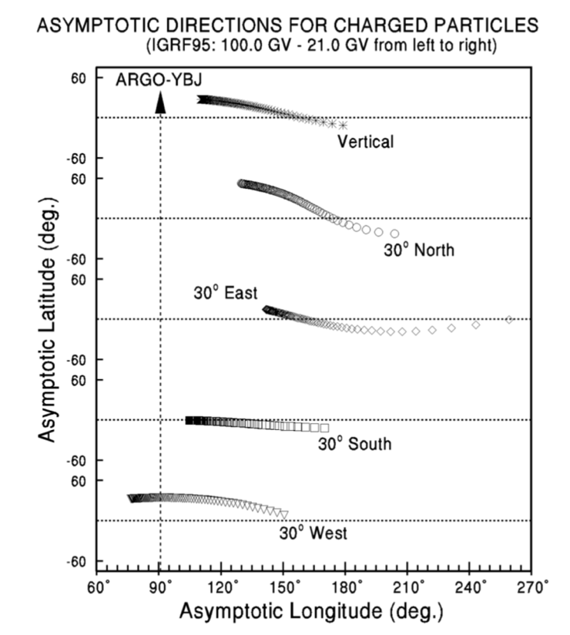
100 GeV
20 GeV
Figure 1. Simulation results from Argo-YBJ for the shifts in the moon shadow for cosmic ray energies from 100 GeV to 20 GeV.

We discuss the design criteria for a QuarkNet detector to measure the moon’s cosmic ray shadow and to distinguish between the above estimates for the angular shift (Δα).

Moon shadow is small – we have to search over much larger portion of sky
The angular size of the moon is 0.5 degrees. To make estimates about the shadow in muon rates let’s assume that is 1 degree. If angular acceptance of a pair of counters in the QuarkNet detector is made to be +-5 degrees, then by comparing areas, the muons lost by hitting the moon are < 1/100 of muon rate in the 10deg x 10deg counter pair. We have to make better than a 1% measurement to see this effect, which forces us to collect 10,000 events at each direction we sample. We could reduce the telescope’s angular acceptance (move counters far apart) at the cost of covering less of the sky when searching for the shadow.

Size of shadow is uncertain – we must measure it
Muons might be reconstructed to the west of the moon’s position with highest energy muons near the moon and lowest energy muons (~2GeV) west by either 10 degrees or 160 degrees. Since the rate decreases with muon or cosmic ray energy most of the shadow is expected to be located at this shifted azimuthal angle and be spread toward the moon. There is also a shift in the elevation angle but it is smaller. Our configuration must be able to locate this shifted shadow wherever it occurs. Our acceptance has to be small enough to be sensitive to the small rate change due to the moon, but also large enough to capture most of the area of shadow.

Where does the moon cross the sky? Where should we look?
Because of the earth’s rotation, the moon crosses the sky from east to west similar to the sun. The moon’s orbit is titled by 5.1 deg with respect to the earth-sun orbital plane. The moon also orbits the earth every ~28 days so it gradually shifts when it crosses its highest elevation each day. Figure 2 shows a schematic of that motion. Note that the moon reaches its highest elevation when it crosses the meridian (due south). Examples of the moon’s position are provided in Figure 3 and the elevation and azimuth for the two days in Nov. 2020 when the moon reaches its highest and lowest elevations is shown in Table 2.

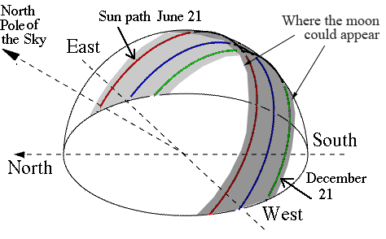
Figure 2. Possible moon positions in the gray area. Peak elevation occurs when the moon passes the meridian, directly south.

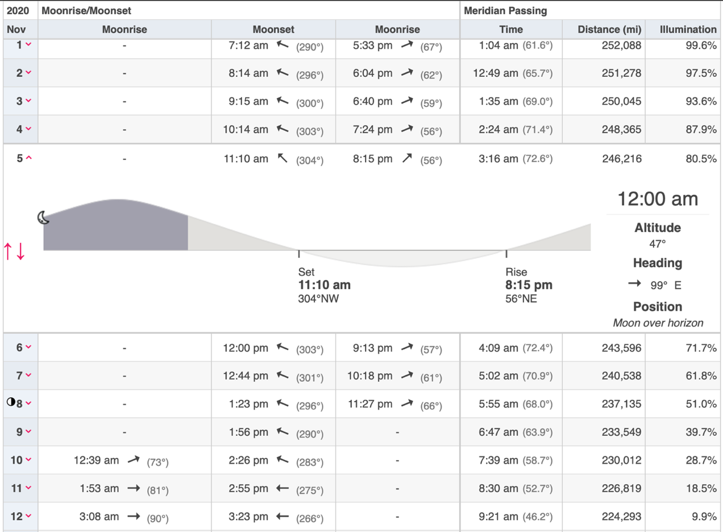
Figure 3. Moon’s peak elevation throughout part of November 2020, from https://www.timeanddate.com . Detailed motion is displayed for Nov. 5th indicating that at midnight the moon is at altitude 47⁰, 99⁰ East; and reaches its peak elevation of 72.6⁰, at 3:16am.

Nov. 5, 2020  Time (am) | Altitude  (degrees) | Azimuth  (degrees) | Nov. 18  Time (pm) | Altitude  (degrees) | Azimuth  (degrees)
12:15 | 50 | 102 | 12:11 | 11 | 141
1:15 | 60 | 116 | 1:11 | 17 | 153
2:15 | 69 | 143 | 2:11 | 21 | 166
3:15 | 73 | 180 | 3:11 | 23 | 180
4:15 | 69 | 220 | 4:11 | 21 | 194
5:15 | 60 | 244 | 5:11 | 17 | 207
6:15 | 50 | 258 | 6:11 | 12 | 220
Table 2. Moon’s elevation and azimuth on two days in November 2020 that represent the highest and lowest peak elevations of the month.

Here is a first suggestion (actually maybe 4th suggestion, but best so far).
- Separate a pair of QuarkNet 25cmx30cm counters by 2m. The angle connection edge to opposite edge for the 25cm widths yields 7.1 degrees. Our Monte Carlo studies demonstrate that most of the events fall 70% of this angle, so within +-5 degrees.
- Point south in the direction of the moon’s position at its highest elevation for that day.
- Change the elevation angle of the telescope every few days.
- To address the shifted shadow, arrange other counters to follow the moons path to the west as shown in Figure 4. That way counters are sensitive to the shifted shadow at earlier times before crossing the meridian when the moon is further east. The lower counters also measure the shadow near the moon’s position after it crosses the meridian.
Where they are located in the path probes different azimuthal shifts and may have to be changed for several separate running periods. We will also want to position the counters along the path to the east to show that the shadow displacement is asymmetric (because of the proton’s positive charge).

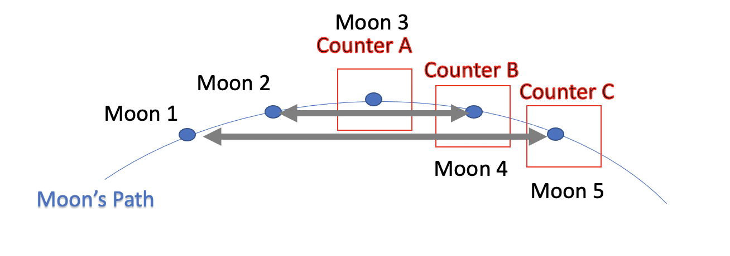Figure 4. Layout of 3 counters along the moon’s path, looking south. In time order: Counter C measures a large azimuthal shift when moon is at position 1; Counter B measures a medium azimuthal shift when moon is at position 2; Counter A measures a zero azimuthal shift when moon is at position 3; Counter B measures a small azimuthal shift when moon is at position 3 and a zero shift from position 4; and Counter C measures a medium azimuthal shift when moon is at position 3, a small shift from position 4, and a zero shift at position 5.

- Since the signal is so small compared to the rate in a counter pair we must be able to correct for muon rate variation due to atmospheric pressure. We must also operate a counter pair that measures the full sky rate, not in the direction of the telescope. That can be a separate CRMD which stays the same over all runs or a clever arrangement of the four counters with small corrections for each elevation change as shown in Figure 5.
- Tilt the counters to reduce the angular acceptance in elevation and overlap some counters vertically to collect normalization data.

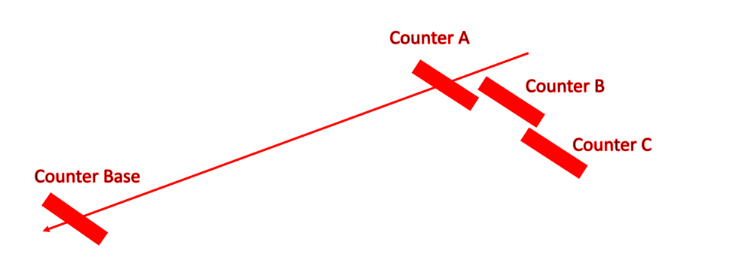
Figure 5. Side view of counter layout.

How much data do we need?
Specific positions of the counters need to be optimized. Referring to Table 2, we see that when the moon is high in the sky, +-2 hours around the peak spans ~155⁰ of azimuthal offset for the shadow, whereas when the moon is low in the sky the range is only 80⁰. We may confine our data collection along the moon’s path (by aligning the telescope) to days when the moon high in the sky and use to other days for background collection. The muon rate for a pair perpendicular to the muon trajectory is approximately 100 events per 10 minutes. The shadow would stay in the counter-pair’s 10-degree acceptance for approximately 30 minutes. Collecting 10,000 events hear one position would require 30 days. Multiple pairs (three) help reduce that to a 10 days, and tilting to counters to limit the elevation angle acceptance by a half increases the signal-to-noise by a factor 2. Of course, we would need to sample several angles. Several months of data collection seems like a reasonable first estimate.

There are many additional issues to consider:
Normalization - additional CRMD or clever tilted counters?
Backgrounds - 2-muon – must be measured; avoid low elevation runs where the effect is larger due to the much smaller cosmic ray rate.
Estimate spread due to positive and negative muons bent by earth’s magnetic field
Harden muon momentum – perhaps 20 Gev Cosmic rays get shifted too much or 2 GeV muons get spread too widely. If we add material in front of our detector, the momentum of detected muons is larger. Should we operate underground?
Simulate the azimuthal shift for our latitude.
Ask MINOS if there is information from the near detector only 100m underground (lower energy).
Also operate setup assuming eastward shifts to collect background rates where no shadow is expected.
Perhaps the ideal locations for the non-southern counters are not directly on the moon’s path?
What is the ideal elevation offset for the non-southern counters?

Conclusions
A single CRMD can be configured to measure the moon’s shadow in cosmic rays. It is a difficult challenge and will require normalization of data to a percent level over several months and at various elevations. This project is very challenging. We are not aware of a measurement of moon’s shadow with cosmic rays below several hundred GeV, even given the existence of large $50M detectors that could attempt this measurement. There is also major discrepancy in the expected azimuthal shift of the shadow among large astroparticle collaboration that we may not be able to resolve. We may be overlooking a major issue, however, our QuarkNet group may be able to attempt a measurement of the moon’s shadow with a few months of data taking.

References
- Adams, et. al., QuarkNet Coordination of a cosmic ray experiment outreach project during a total solar eclipse, 367th International Cosmic ray Conference – ICRC2019, 2019.
- Solar eclipse and cosmic ray flux, submitted to the Physics Teacher, 2020.
- Eclipse_CR_azimuthal_shift word document on the group’s eclipse website
- MINOS Collaboration, Adamson, P., et. al., Observation in the MINOS far detector of the shadowing of cosmic rays by the sun and moon, Astroparticle Physics, Volume 34, p.457-466 (2011).
- Storini, M., D. F. Smart, M. A. Shea. 2001. ‘Cosmic Ray asymptotic directions for Yangbajing (Tibet) experiments’ Proceedings of the 27th International Cosmic Ray Conference. Hamburg, Germany. 07-15 August, 2001. Under the auspices of the International Union of Pure and Applied Physics (IUPAP), p.4106-4109.

