Speed of Muon

Go to https://www.i2u2.org/elab/cosmic/home/index.jsp
Username: GoCosmic
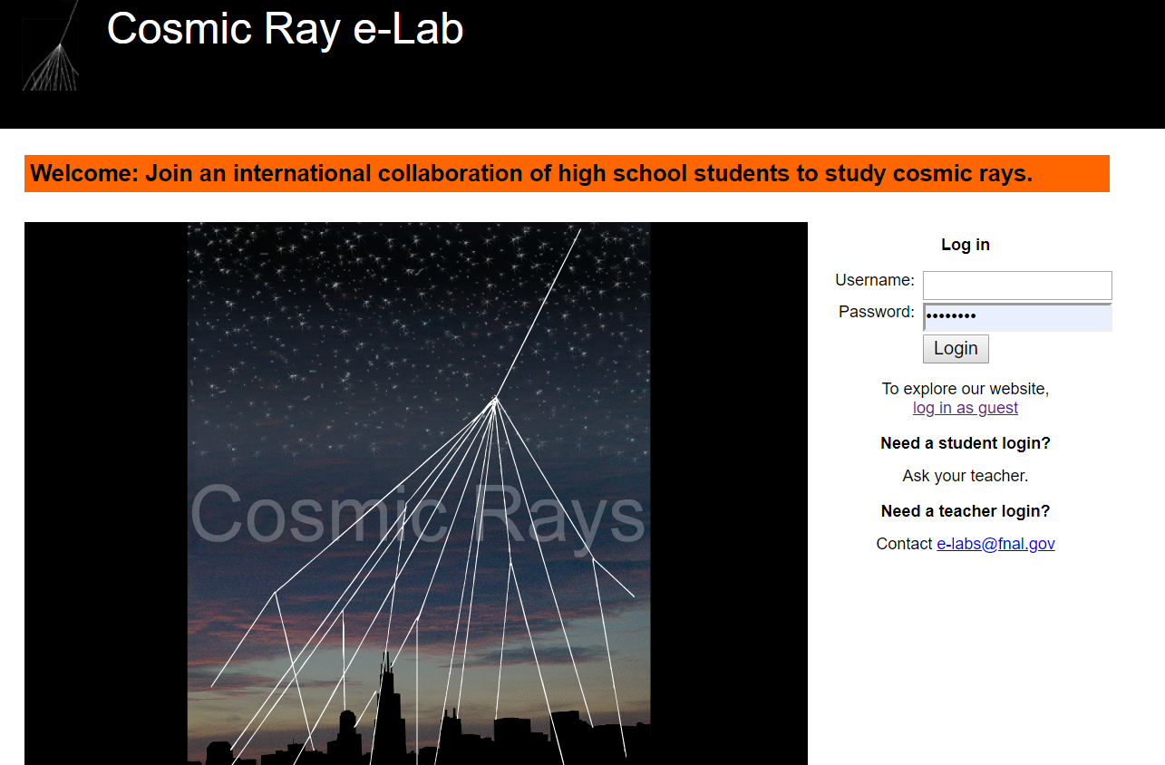

On the landing page, select Data
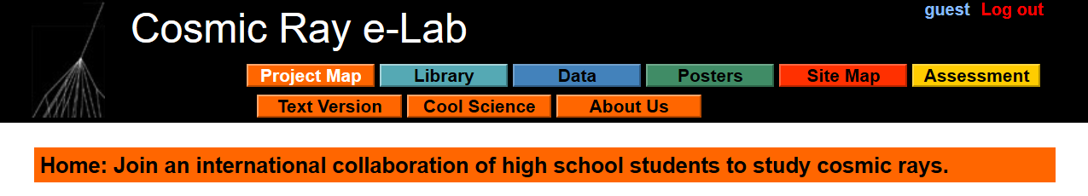

From the Data landing page, select T of F (Time of Flight)
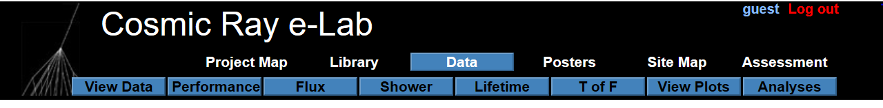

On the Time of Flight landing page, you need to make several selections.
- On the first drop-down box, select Detector ID.
- In the middle box, enter 6200. DAQ 6845 will also work, but from 01/12/2021.
- Select >Advanced Search and use the Start Date of 09/01/2019 for 6200, 01/12/2021 for 6845
- Press Search Data.
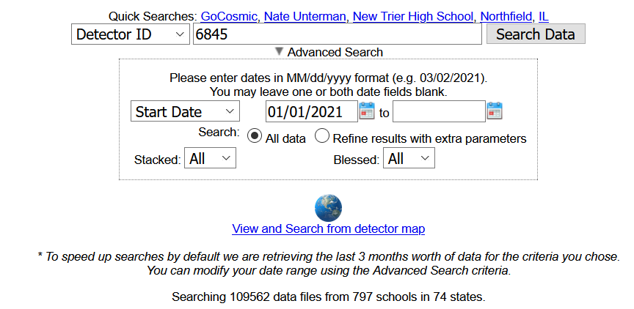

Part of the screen is shown below.
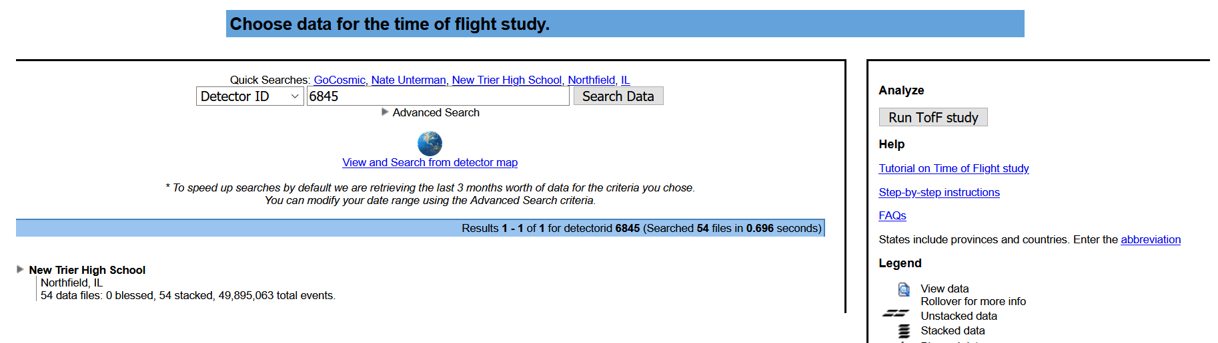
Two important parts: to get to the data, click on the triangle. Please note the Run TofF study.
It will expand, showing months and year. Click on the triangle to expand January 2021.
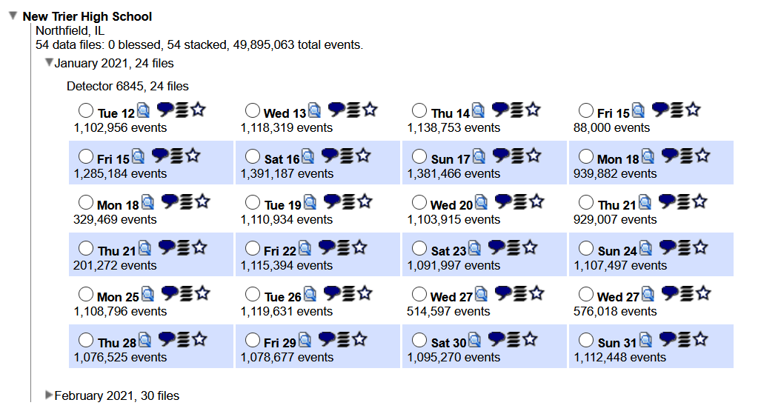
There is much to learn here, but for the purposes of this tutorial, select the circle for Tuesday 12.January.2021. There are 1,102,956 events. Then click the Run TofF study on the right side of the screen as noted above.
This should be the result:
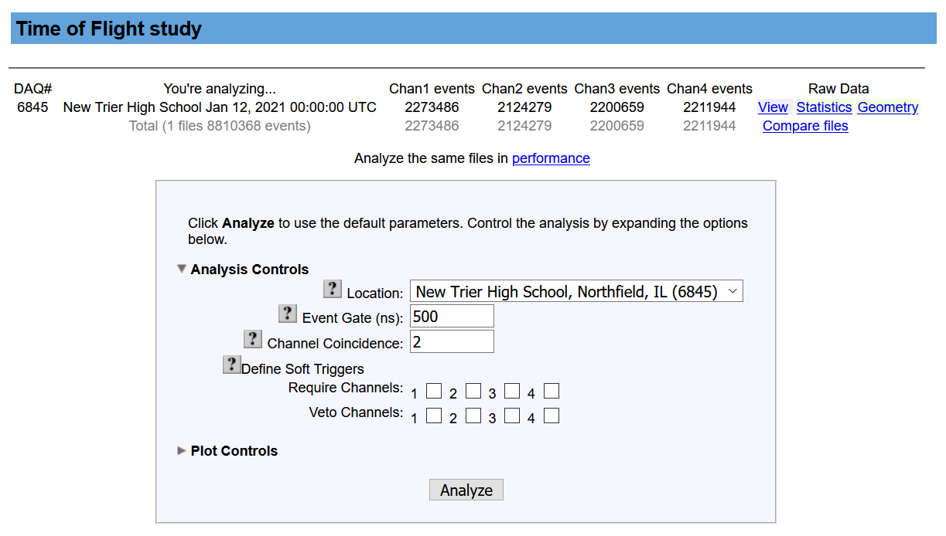
Change the Event Gate (ns) from 500 to 50, and click on Analyze at the bottom.

You will get a progress bar. It may take a minute or two, depending on available computer time at Notre Dame University, web traffic, etc. The results are 6 graphs. If the frames come in, but not the graphs, try the refresh button on your browser.
With slight truncation at the bottom, the results should look something like this:
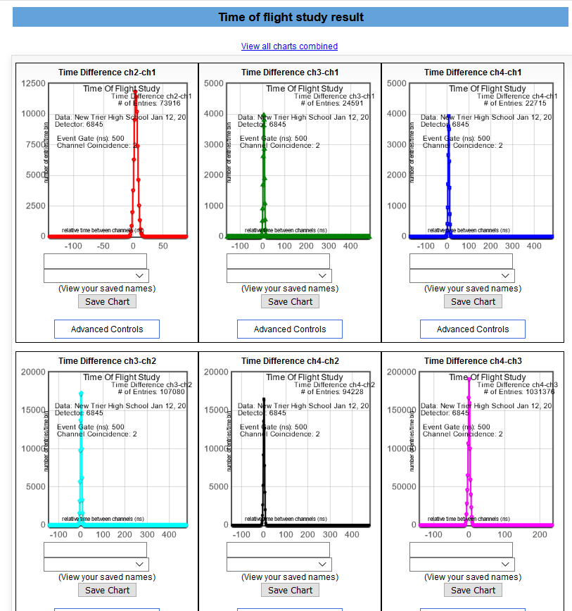
The titles of the graphs tell you which counters are being compared. Hover over the Advanced Controls (it turns blue) near the bottom of each graph rectangle to get the Mean time in nanoseconds (10⁻⁹).
For Channels 1 and 2 (red graph), the pop-up box shows a mean value of 4.04 nanoseconds. All of the other items are for adjustments that we will not worry about at this time.
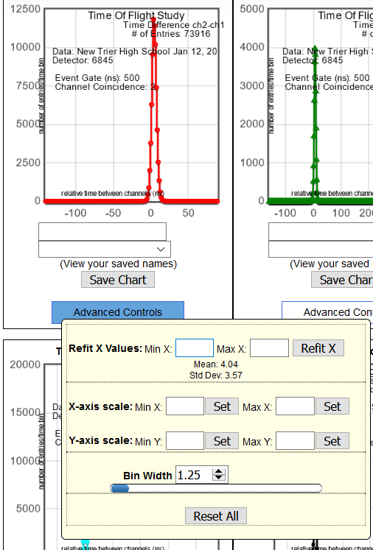

You will need to record this in a spread sheet. Initially, the spreadsheet should look like:
Speed of Muon
DAQ | 6845 | Date | 12.Jan.2021
Counters | Time (ns) | Separation (m)
12 | 4.04E-09
13
14
23
24
34

Proceed to hovering over the Channels 1-3 graph, enter the time . . . through all six graphs.
The data table is shown below.
Speed of Muon
DAQ | 6845 | Date | 12.Jan.2021
Counters | Time (ns) | Separation (m)
12 | 4.04E-09
13 | 5.63E-09
14 | 5.49E-09
23 | 1.73E-09
24 | 1.58E-09
34 | -5.00E-11

The hard part is done. But wait! We need the separation. Go back to eLab, and at the top of the page, select Upload then click on Geometry.
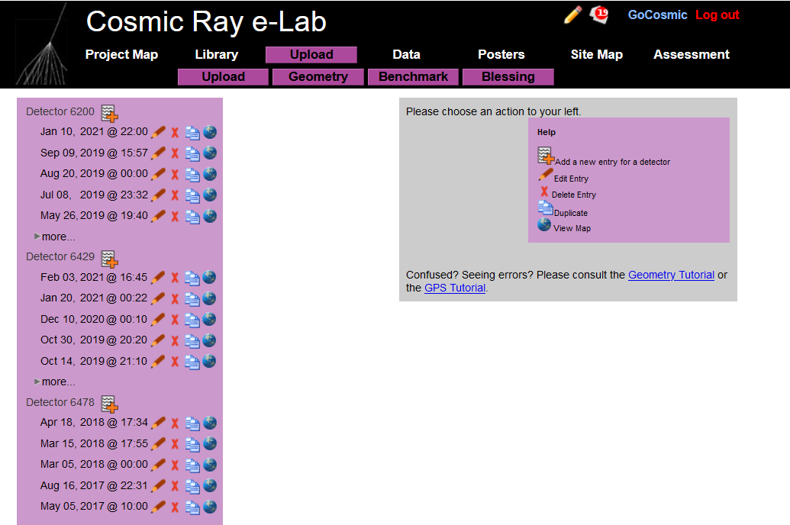

Scroll down along the left column until you find Detector 6845. Now you must think. Since we are working with 12.January.2021, if we use a geometry after this date, it will be wrong. The geometry for this file is Jan 08, 2021 @ 20:37. Select the pencil icon.
BE CAREFUL. You are in edit mode. It is important NOT to change anything. If by accident you change something, DO NOT SAVE.
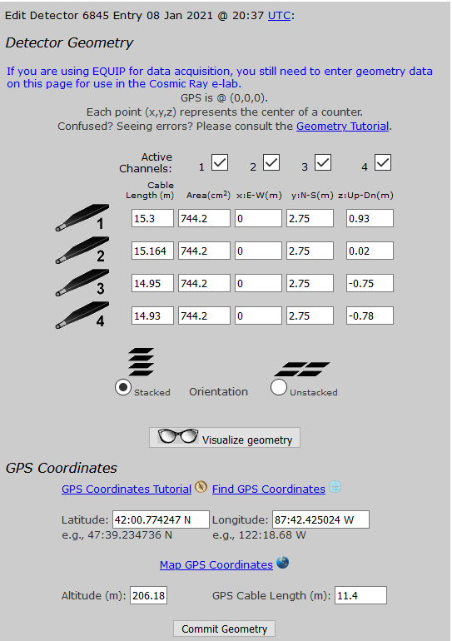
We are interested in the z-Up-Dn(m) column to the far right. Math time. You need to find the difference among all pairs: 1-2,1-3, 1-4, 2-3, 2-4, and 3-4. These get entered into the data sheet. (Hint: It will be easier after this, since the vertical geometry has not changed since January 2021. All files to date have the same geometry, so this step will be necessary only if you go to another detector or if you are out of date range.)
Speed of Muon
DAQ | 6845 | Date | 12.Jan.2021
Counters | Time (ns) | Separation (m)
12 | 4.04E-09 | 0.91
13 | 5.63E-09 | 1.68
14 | 5.49E-09 | 1.71
23 | 1.73E-09 | 0.73
24 | 1.58E-09 | 0.76
34 | -5.00E-11 | 0.03

You want to do a Scatter Plot. Select the data and Graph it.

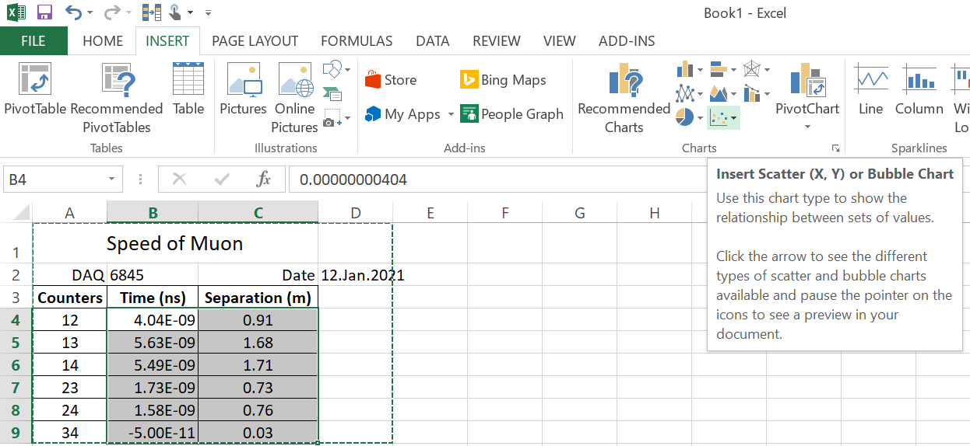

Select Scatter (just points, no lines).

We should really label the axes, title, etc. . . . . right click on any point.
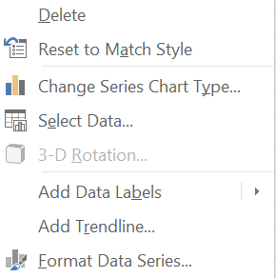
Select Add Trendline. . . near the bottom.

You should get a pop-up menu that will allow you to select linear, and check boxes for Equation and R².

Click on the equation, and we hope a dialog box comes up for NUMBER with a Category and drop down menu. Select Scientific.

The velocity is the slope, at about 2.63 * 10⁸ m/s. A tad slow.

This is the measurement for one day. If we take a month and average the values, we will be much closer to a truer value.

