,,,

78” height

96”

22” Front

12” Depth

¾” Plywood
48”
78”

22”

12”

12”

Need 4 shelves, ¾ X 12 X 22
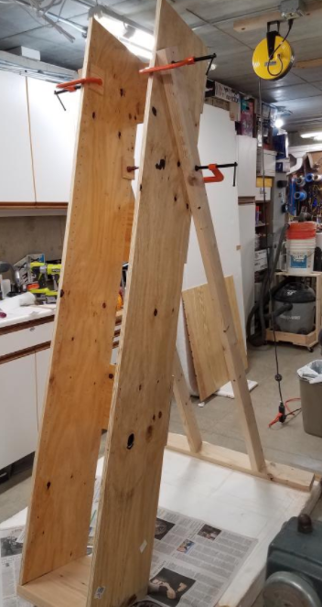

YOKE

23.5”
8’

4’

2 X 4 2-8 foot 1-4 foot

Screws, Velcro or other strap holder
Clamps: 12 for shelves
4 for yoke

