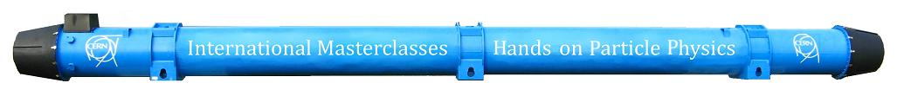
CMS International Masterclasses
Join us on a journey to study the smallest building blocks of matter! Data samples from the CMS Experiment at CERN's Large Hadron Collider (LHC) are ready. Make your own measurements. Follow the menu buttons above: the current J/Ψ Exercise for Masterclass 2011 and the W/Z Exercise to be released later. Students will find information in the Library and videos. Explore...and then let's do some 21st century particle physics!
