

Count the total number of W-electron candidates and the total number of W-muon candidates.

Calculate electron-to-muon ratio:

|  |  |  |
| --- | --- | --- |
| No. e | No.  | e/ |
|  |  |  |

*Contribute your numbers of e and  to group totals.*

Your Z mass plot:

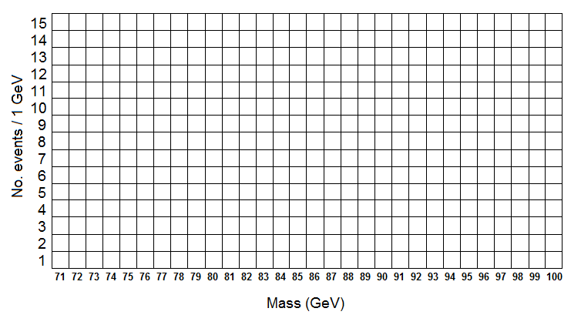

Place an X in the appropriate mass bin for each event. Start from the bottom so that the vertical axis represents the number of events in that bin.

*Contribute the total number of events in each bin to the group mass plot.*